TCP TEXT MESSAGE
Program User Manual

This guide will show you how to use TCP Text Message, a simple command line tool for sending a text between a client pc and a server pc. TCP Text Message currently only provides ‘echo’-type command support, but future versions hope to implement ‘reply’-type commands between one client and another.

How to get started:
All of the code for TCP Text Message is packaged within the tcp_text_message.zip file. In this file contains all of the source code and an executable for a Linux Ubuntu 24.04.3 distro. If you would like to run this program on a different operating system, you must recompile the source code with the makefile provided.

Once you have the appropriate executable, all you need to do is open a command line in the same directory as the executable, as shown below:

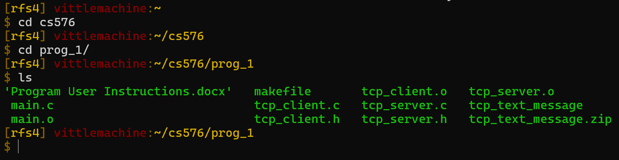

Executing the program is simple. TCP Text Message requires two arguments to run; a <program_type> and an <ip_address>.

Currently, the options for program type are ‘server’ and ‘client’. ‘server’ will start a text message server that will receive texts from clients, process the texts, and return the results. ‘client’ will open a texting interface to send and receive texts from a server. As you can see, the same program can operate both sides of the tcp messaging service depending on which type you choose to open.

The ip address will be the ip address and port you choose to operate with, specified in standard IPv4 format. The ip address is mandatory, but the port will default to 8000 if not specified. Note that this address and port will represent different things depending on which program type you choose to run with. If you start a server, this address and port will be the ones that the server uses to listen from. On the other hand, if you run a client, the address and port will be for the server you want to connect to. Due to routing and firewall limitations, the address will often be limited to the ones within your home network, or even your own computer. Keep this in mind when attempting to connect.

With the arguments in the following order, you can type the following into your command line to run:
./tcp_text_message <program_type> <ip_address>

Server Example:

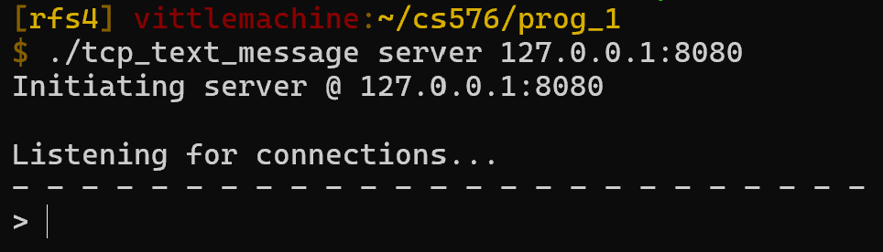
Client Example:

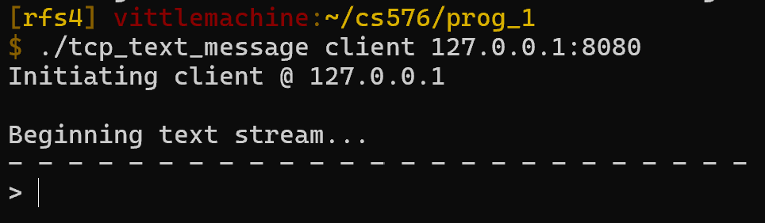
Once the interface pops up, you are ready to send!

Operating the Server:

